**ATAR Physics**

**Unit 1**

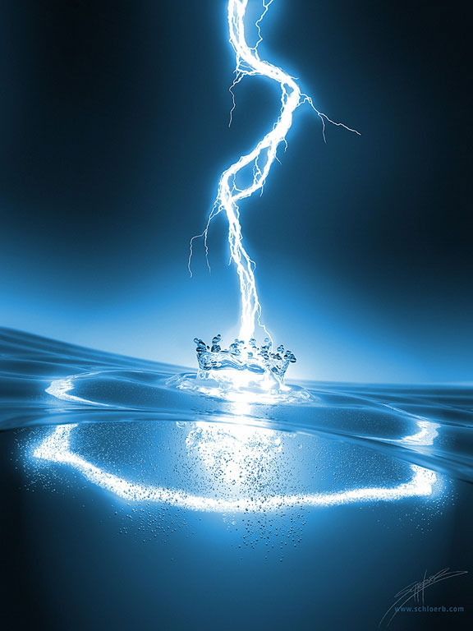

**Electrical Fundamentals**

There are two types of charge that exert forces on each other.

**ELECTROSTATICS**

* 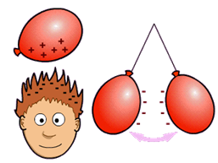**Static** **electricity** is the build-up of a positive or negative charge on an object. While you can’t often see static electricity, you can often feel, and/or hear the effects of it when it discharges. Some examples are:
* lightning
* getting “zapped” by a car door.
* charging a comb then making your hair stand up
* using a Van de Graaff Generator.

**Charge and Atomic Structure:**

* Static electricity is the result of a build up of charge.
* To understand static electricity you must first know about the atom.
* Draw a labelled diagram of an atom to show the positions of the *electrons, protons* and *neutrons.* Label each with their charge.

(area where electrons are found)

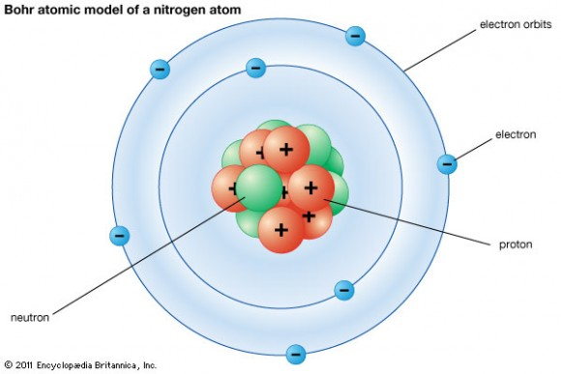

(positive charge)

(negative charge)

(no charge)

* As the proton is firmly locked in the nucleus, all electric phenomena are due to the *movement of electrons* only.
* a. When an object gains electrons it has a net  **___________________** charge.
* b. When an object loses electrons it has a net **___________________**  charge.
* All *like* charges will  **__________________** each other, whereas all *unlike* charges will  **___________________** each other.

**The Van de Graaff Generator:**

[**http://www.youtube.com/watch?v=I2G0IdTWGQU**](http://www.youtube.com/watch?v=I2G0IdTWGQU)

[**http://www.nationalstemcentre.org.uk/elibrary/resource/2088/van-de-graaff-generator**](http://www.nationalstemcentre.org.uk/elibrary/resource/2088/van-de-graaff-generator)

**(Note: The information appears after the Discovery Introduction, just wait.)**

* Explain why a person’s hair stands on end when they are touching a Van de Graaff Generator.



________________________________________________________________________________________________________________________________________________________________________________________________________________________________________________________________________________________________________________

_______________________________________________________________________________________________________________________________________________________

**NP 140-3**

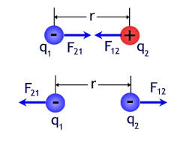**FORCES BETWEEN CHARGES – COULOMB’S LAW**

* The French physicist, Charles Coulomb (1736-1806) investigated the forces between two charged spheres.
* He showed that the magnitude of the force, F, varied inversely with the square of the distance between the spheres and varied directly with the product of the charges:

<https://phet.colorado.edu/sims/html/balloons-and-static-electricity/latest/balloons-and-static-electricity_en.html>

**EP Expt 9.1 p 92, Inv 9.3 p 96**

Electric current is carried by discrete charge carriers; charge is conserved at all points in an electrical circuit

*This includes applying the relationship*



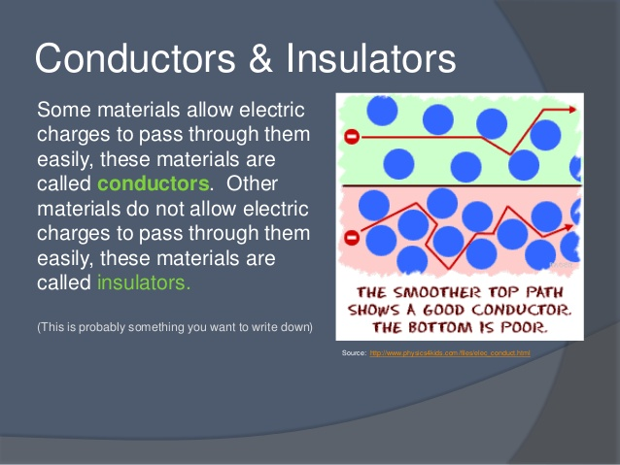**Conductors and Insulators**

* A conductor is a material through which an electric charge is readily transferred.
* As electricity is related to the movement of electrons, conductors tend to be materials in which there are free electrons to carry the charge.
* Most metals are good conductors as they have electrons that are free to travel through the material.
* Carbon, a non-metal, is also a conductor for this reason. Some semi-metals can also conduct electricity.
* An insulator is a material through which an electric charge is not readily transferred (no free moving electrons).
* Good insulators are glass, mica, hard rubber, sulfur, silk, dry air and many plastics.

**NP p143-5 QS 5.1 p146**

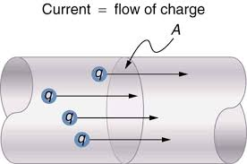**The Coulomb and Electric Charge**

* The unit of charge is called the **coulomb (C).**
* It is customary to define the coulomb (C) in terms of the **ampere** - the unit of electric current.
* Along with the kilogram, meter, and second, the ampere is to be considered the fourth fundamental unit – all other electrical units are derived units.
* 1 coulomb = 1 ampere second.

q = charge in coulombs (C)

I = current in amperes (A)

t = time in seconds (s)

* Mathematically, we can express this as where
* A microwave is used for 1.5 minutes to cook some food. If it uses 450 C of charge, what current does it draw?
* A hairdryer needing a current of 6.00 A is used for 10.0 minutes, what charge flowed through the hairdryer during this time?

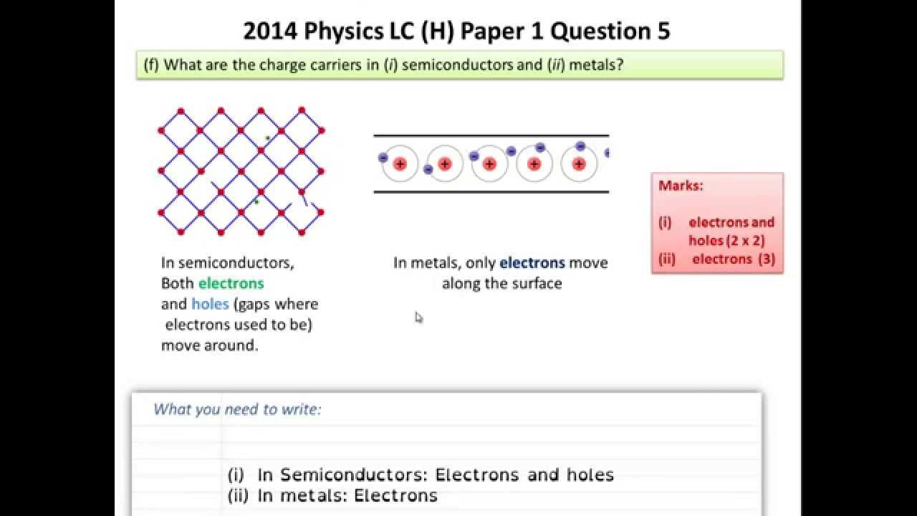

**Charge carriers**

* 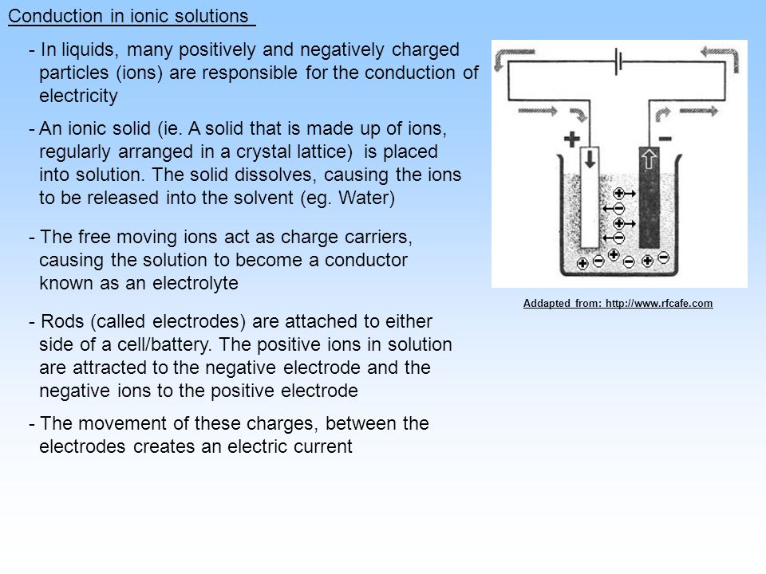Electrically charged particles that are free to move are referred to as **charge carriers**.
  + Electrons are the charge carriers in a metal.
  + Ions in solution are the charge carriers in electrolyte solutions.
* Electric charge can neither be created nor destroyed – it must be conserved.
* The net electric charge, the amount of positive charge minus the amount of negative charge is always conserved.

**NP p149-53 QS 5.3 p153**

* Explain why metals are good conductors and why non-metals are good insulators.

________________________________________________________________________________________________________________________________________________________________________________________________________________________________________________________________________________________________________________

* What is the function of a lightning rod on a building?

________________________________________________________________________________________________________________________________________________________________________________________________________________________________________________________________________________________________________________

* On a dry day people often get small electric shocks when they enter or leave a car. Use your knowledge of static electricity to account for this affect.

________________________________________________________________________________________________________________________________________________________

* A petrol tanker often becomes electrically charged as it drives along to its loading or unloading points.
* How does it become electricity charged?

________________________________________________________________________________________________________________________________________________________

* Why is this dangerous?

________________________________________________________________________________________________________________________________________________________

* What do petrol tanker manufacturers include in their design to reduce the dangers of static build-up on petrol tankers?

________________________________________________________________________________________________________________________________________________________

________________________________________________________________________________________________________________________________________________________

________________________________________________________________________________________________________________________________________________________

* Max was on coffee duty at church, and had to put out, as close together as possible, 150 empty polystyrene cups to be filled later. They were initially stacked 25 high in cartons. Suggest a reason why Max found it difficult to set them out so they stayed stable.

________________________________________________________________________________________________________________________________________________________

________________________________________________________________________________________________________________________________________________________

* A spark between your hair and your comb on a dry day moves a charge of 2.00 x 10-9 C. The spark lasts for 1.00 μs. What current flows in this case?
* A torch circuit carries a current of 325 mA for 4.50 minutes. Calculate the total charge that has left the battery in this time.

**ELECTRIC FIELDS**

<http://vnatsci.ltu.edu/s_schneider/physlets/main/efield.shtml>

**(Shows different fields both with a positive and negative charge)**

* An electric field is defined as an area of influence around a charged object. Field lines are used as a means of providing a picture of an electric field; however these lines do not actually exist. Line density indicates the strength of the field and is proportional to the charge magnitude.

<http://www.youtube.com/watch?v=7vnmL853784>

a. Field around a point charge where the point is (i) negative, and (ii) positive.

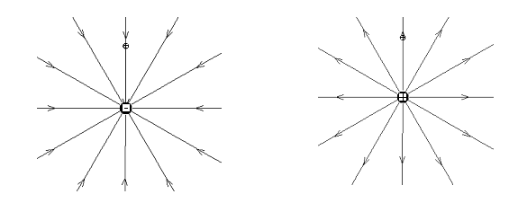

b. Field between two point charges, (i) two different charges and (ii) both the same charge

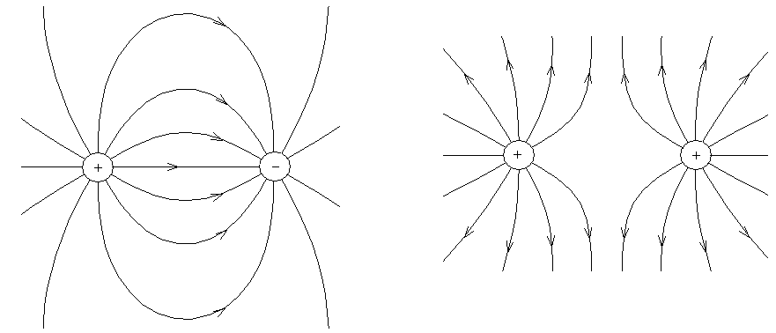

c. Field between two plates, one positive and one negative.

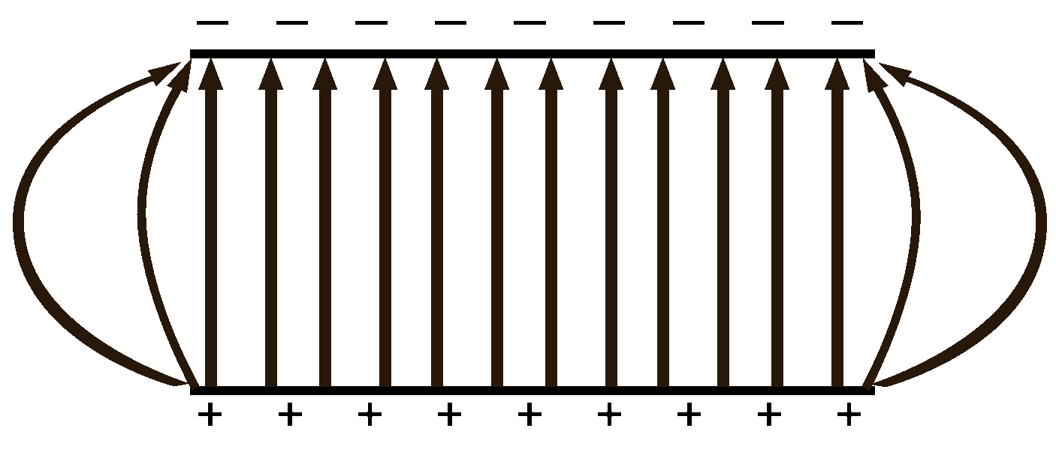

* 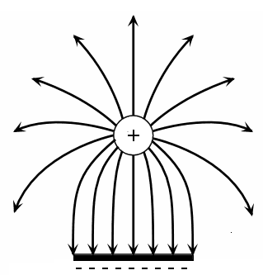Field between a plate and a sphere where (i) both the same charge and (ii) different charges.

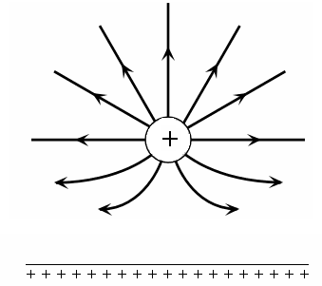

Energy is conserved in the energy transfers and transformations that occur in an electrical circuit.

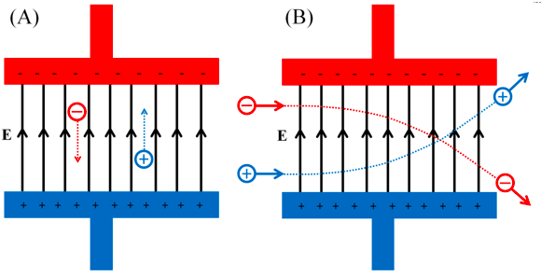

* Energy must be conserved when charged particles move through electric fields.
* A stationary charge subjected to an electric field will experience a force on the charge and cause the charge to move.
  + Positive charges will move one way, negative charges in the opposite direction.
  + At the moment the field is applied, the charge has 0 kinetic energy but electrical potential.
  + As the charge moves, it increases kinetic energy, but the electrical potential energy reduces. The sum of the energies is always CONSTANT.

**ELECTRICAL ENERGY AND ELECTRICAL TRANSFORMATIONS**

* 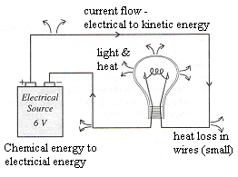Electrical energy is not used up when you use an appliance, it is transformed.
* The energy source is usually a cell, battery or generator. Batteries contain stored chemical energy which is transformed to electrical energy of the electrons which is then transformed to kinetic energy as the electrons move around the circuit and collide with the atoms of the various parts of the circuit through which they are passing.
* The energy lost by the electrons in the collisions becomes vibrational energy of the atoms so the circuit gets hot.
* If a globe is one of the components of the circuit, the filament inside the globe will give of light and when it is hot, heat energy.

**Question:**

Select an electrical device. Name the device: ___________________________

Explain the energy transformations within this system.

____________________________________________________________________________

The energy available to charges moving in an electrical circuit is measured using electric potential difference, which is defined as the change in potential energy per unit charge between two defined points in the circuit

*This includes applying the relationship*



* Consider a positive charge situated at B.
* 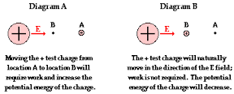B will be repelled by the charged sphere.
* Therefore, in order to move the charge from B to A, energy must be supplied.
* There is a difference in potential between A and B.
* As an object falls towards Earth, it moves from a point of **higher gravitational potential** to a point of **lower gravitational potential**.
* The SAME THING happens with electrical charge – it moves from a point of **higher electrical potential** to a point of **lower electrical potential**.

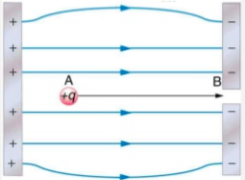

* The amount of work or energy required to move a charge from B to A depends on the size of the charge, q, and the difference in potential between A and B.
* This is summarised as: W = Vq

Energy is required to separate positive and negative charge carriers; charge separation produces an electrical potential difference that drives current in circuits.

* To separate charges requires energy.
* 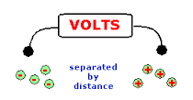Rubbing two surfaces together requires kinetic energy that can separate electrons to form positive and negative static charges.
* In a dry cell, chemical energy in a chemical reaction creates electrons that can move to one end of the cell.
* Both of these processes create an electrical potential difference.
* If two points have a different amount of charge, they have a different potential.
* It you connect these two points using a conductor, either positive or negatively charged particles will flow until they reach the same potential.
* The flow of charged particles is called an electric current.
* In chemical solutions, both positive and negative ions can flow however, in a metallic conductor, free electrons will move towards the positive point (lower potential).

**NP p146-8 QS 5.2 p149**

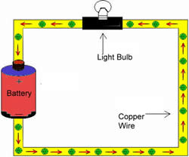**POTENTIAL DIFFERENCE IN CIRCUITS**

**Potential Difference**

* 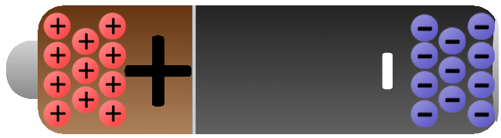In an electrical circuit, when two points exist at a different potential and are connected, then electrons flow and we have an electric current.
* 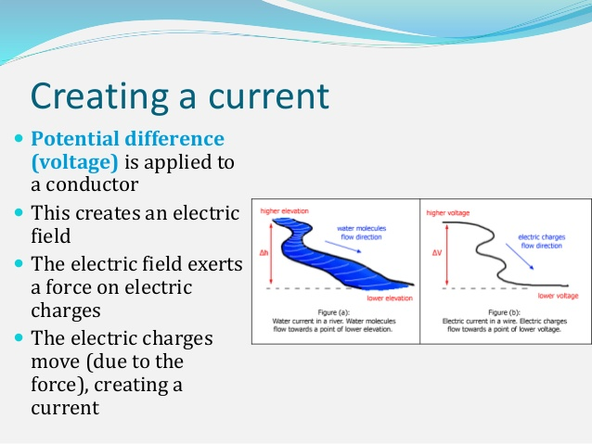Electrical potential difference is measured in terms of the amount of work (energy) that has to be done to move a charge from one place to the other. The unit of electrical potential difference is the VOLT (V).
* Potential difference (voltage) applied to a conductor creates an electric field.
* This electric field exerts a force on electric charges.
* The electric charges move (due to the force), creating a **current**.
* If, in moving a charge of one coulomb from one place to another, one joule of work is done (or 1 joule of kinetic energy is gained), then the electrical potential energy difference between the two places is one volt. Hence,

 where V = Potential energy in volts (V)

W = work done in joules (J)

q = charge in coulombs (C)

* If you re-arrange the formula you get:

W = Vq,

but q = It,

therefore **W = Vq = VIt**

* Hence it can be seen that there is a relationship between work (energy), charge and potential difference.

**Examples:**

1. A 12V battery supplies 10.0 μC of charge to a toy car. What work is done in moving the charge?

2. A current of 10.0 mA flows across a potential difference of 2.00 x 102 V for 3.00 minutes. What work is done?

**EP p90-1 Problem Set 9**

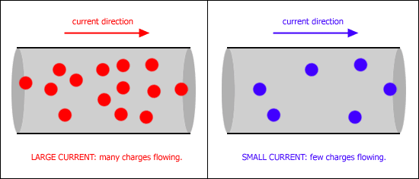**ELECTRIC CURRENT**

* When charges move, they form an electric current.
* Current is the rate of transfer of charge or the **rate of flow of electrons** or the **rate of flow of charge**.
* The unit of electric current is the ampere (A). If one coulomb of electric charge passes any one point in one second, it is said to form one ampere (A) of current.

q = charge in coulombs (C)

I = current in amperes (A)

t = time in seconds (s)

Mathematically, we can express this as where

**CONVENTIONAL CURRENT AND ELECTRON CURRENT**

* Prior to 1897 when Thomson discovered electrons, scientists believed that electricity was a flow of ‘electric fluid’ which moved from a positive potential to a negative potential (flow of positive charge).
* By the time they realized that negative electrons flowed in the opposite direction, the idea of a positive flow of charge was too firmly built into the theory of electricity.
* 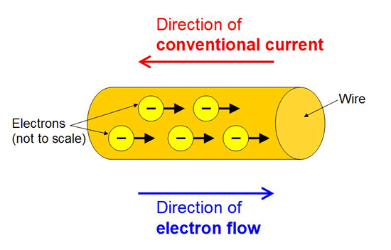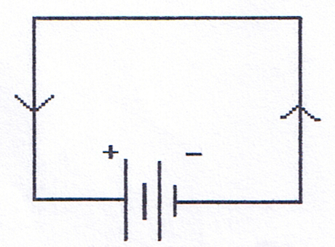As current is the rate of transfer of charge, we now call the flow of positive charge **conventional current** and the actual flow of electrons, **electron current.**

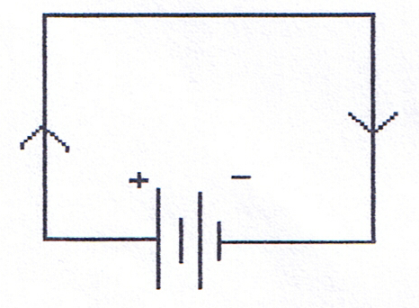

|  |  |  |
| --- | --- | --- |
| ***Conventional Current:***  *Defined as being in the direction of charge transfer. When we refer to the direction of current in a circuit we are referring to conventional current.* |  | ***Electron Current:***  *Electrons flow from a region of higher potential to a region of lower potential, in other words, from negative to positive. Electron current is used to describe the actual movement of electrons.* |

**DIRECTION CURENT AND ALTERNATING CURRENT**

* In direct current, or DC circuits, the flow of electricity is only one way.
* The polarity of the potential difference stays constant, in other words, the positive terminal is always positive and the negative terminal always negative.

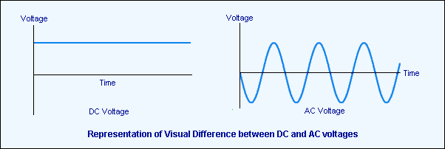

* In alternating current, or AC circuits (studied next year), the polarity of the potential difference can change in a regular way, so that the charge first flows in one direction, then in the other.
* The Australian mains electricity supply is 240 V AC, changing polarity 50 times a second; that is a frequency of 50 Hertz.
* The choice of AC or DC is determined by the situation in which electricity is needed.
* Any battery-powered supply will be DC, while the domestic mains supply is AC, due to the fact that a changing potential difference is needed to run transformers, which form an essential part of mains supply systems.
* In year 11 Physics, you will only deal with DC circuits although you will need to know the difference between the two currents.

Power is the rate at which energy is transformed by a circuit component; power enables quantitative analysis of energy transformations in the circuit

*This includes applying the relationship*



**Electrical Power**

* Consider a 1000 W bar heater. It converts electrical energy into heat energy. If it were 100% efficient, it would convert 1000 J of electrical energy into 1000 J of heat, every second.

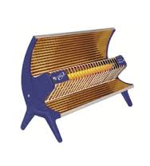

1000 J of heat energy per second

1000 J of electrical energy per second

* Power is how quickly energy (work) is produced or used, therefore power is equal to the work done divided by the time taken. The unit for power is the watt (W).

 but we also know that work, W = Vq

therefore we can say that 

now current is described as the rate of flow of charge or



therefore = VI where V = potential difference (V)

OR P = VI P = power (W)

I = current (A)

* Using Ohm’s Law, V = IR, two other formulas for power can be derived:

P = I2R and 

*.*

**Electrical Energy Used**

The energy consumed by an electrical appliance depends upon the rate of energy use (power rating) and the time for which it is operating. Knowing that work is equivalent to energy,

W = Pt or E = Pt

but P = VI so substituting for P,

E = VIt where E = energy used (or work done) in joules (J)

V = potential difference supplied (V)

I = current (A)

t = operating time (s)

**Questions:**

* 1. A motor car’s two headlights are each rated at 50.0 W and operate on a 12.0V power supply.

Calculate the following:

1. The current flowing in each headlight when they are in use.
2. The charge passing through each globe every second.
3. The total energy consumed by the two headlights during a 2.00 hour night journey.
   1. What is the current drawn by a 2.50 x 103 W electric kettle if is operates on a 240 V supply?
   2. If the kettle in question 2 is used for 2.80 minutes, how much electrical energy will it use?
   3. A heating appliance is rated at 2.40 kW with a current of 10.0 A. Determine
4. the PD across the appliance,

1. amount of heat converted from electrical energy per minute,
2. the total charge flowing through it per minute.

**NP p163-7 QS 5.6 p167**

**WSG 3.1 p 63-8 Q’s 1-8 p79**

**EP p97 Problem Set 10**

Resistance depends upon the nature and dimensions of a conductor

**RESISTANCE**

* The resistance is the measure of how much ‘friction’ a conductor presents to an electric current. Consider again the factors that affect resistance:
* 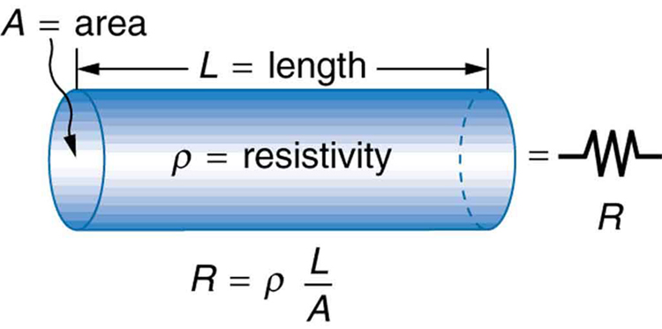Length (l). It is found that resistance increases proportionately with the length of a conductor

e.g. R ∝ l

* Cross-sectional area (A). The greater the cross-sectional area of a conductor, the smaller its resistance.

e.g. R ∝ 1

A

* Resistivity of the material (ρ - pronounced ‘rho’). An electrical property of materials is their resistivity. The resistance of a conductor is proportional to its resistivity.

e.g. R ∝ ρ

* When making electrical appliances the resistance of the material must be taken into account.
* The power cord of the electric jug is made of copper wires. Therefore, its electrical resistance is low.
* The resistance of the heater element must be high. It is, therefore, made of a metal alloy with a high resistivity. A metal alloy commonly used for this purpose is nickel-chromium.

**NP p157-160**

**CONNECTING COMPONENTS IN DC CIRCUITS**

**Electrical Components**

* Electrical components can be divided into four main areas:
  + conductors e.g. wires
  + resistors e.g. lights, electrical appliances
  + sources of potential e.g. batteries, chemical cells, power packs
  + switches to control the flow of electrons.
* Electrical circuits can often be very complex so to simplify things, circuit diagrams are used with circuit symbols for the components.

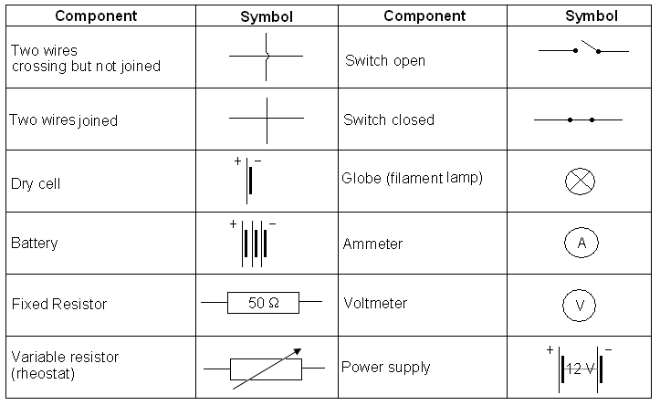

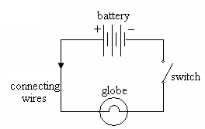**The Basic Circuit:**

* The basic circuit has a power source, switch, resistor (globe) and leads.
* *Label the diagram for conventional current.*
* Besides the basic circuit, there are three main types of circuits:
* **Series** – in which all parts of the circuit are connected in a continuous circle (although for easy reading, we usually draw a rectangle shape). These are simple circuits as there is only one path for the current.
* **Parallel** – parts of circuit connected in parallel so that each part has its own path for the current.
* **Complex** – combination of series and parallel connections. Most electrical devices are complex circuits.

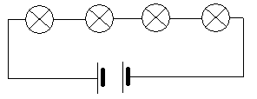

**SERIES CIRCUITS:**

* In a series circuit, there is only one path for the current as shown below.
* Cheap Christmas tree lights are a good example of this type of circuit or a switch for lights.

# PARALLEL CIRCUITS

* These circuits are set up so that each electrical device has its own path for the current as shown below.
* The sum of the currents in the different parts of a parallel circuit is equal to the total current.
* House lights are set up in parallel so that if one goes out the rest stay on.

**NP p154-6 QS 5.4 p154**

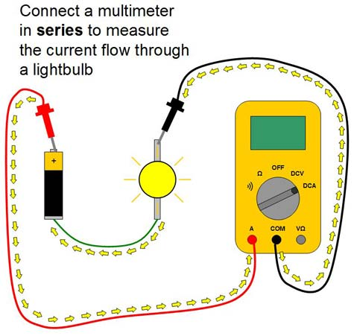**USING AMMETERS AND VOLTMETERS**

Ammeter:

* An ammeter is a device that measures how many electrons pass a point in the circuit in a given time, that is, it measures current (in amperes).
* To be able to measure all electrons, it must be placed in the actual circuit (in series).
* The red lead is connected closest to the red plug on the power pack; likewise, the black lead is connected closest to the black plug on the power pack.
* On the right, draw a labelled diagram of a multimeter showing how to read an ammeter.
* ***Never put an ammeter in parallel.***

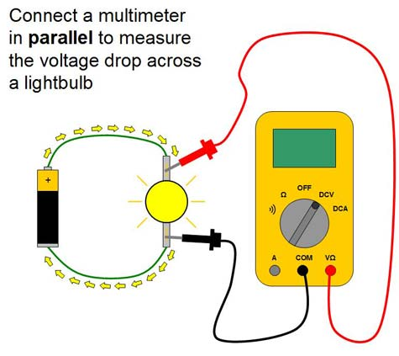Voltmeter:

* A voltmeter is a device that measures the difference in charge from one point to another, that is, the potential difference used by an electrical device.
* Voltmeters are placed in parallel across the required electrical component (e.g. globe) to determine the voltage.
* Draw a labelled diagram of a multimeter showing how to read as a voltmeter.

Resistance for ohmic and non-ohmic components is defined as the ratio of potential difference across the component to the current in the component

*This includes applying the relationship*

**ELECTRICAL RESISTANCE – OHM’S LAW**

* When a current flows in a circuit, there is a resistance to the flow that results in energy losses from the electric circuit.
* Materials that offer electrical resistance are called **resistors.**
* The ratio of the potential difference (sometimes called voltage and measured in volts - V) to the current for a component is called the resistance and it is measured in **ohms** with the unit being the Greekletter Ω (pronounced ‘omega’).
* A resistance (**R**) of 1 ohm is experienced if there is a potential difference (**V**) of 1 volt per 1 ampere of current (**I**) flowing, therefore:

Where: R = resistance in ohms (Ω)

V = potential difference in volts (V)

I = current in Amps (A)

* Some of the factors that can affect electrical resistance are:
* length of the wire
* cross-sectional area of the wire
* temperature of the wire
* the material from which the wire is made (resistivity)
* Georg Simon Ohm was the first scientist to study the relationship between potential difference and current.
* Any conductor for which the potential difference vs current graph is a straight line is called an **ohmic** **conductor** the relationship is said to be directly proportional starting at 0,0 (see graph (b) below).
* The resistance of some conductors can be affected by light or temperature and a plot of voltage vs current for such resistors produce a curved line (see graph (c) below).
* These phenomena give rise to some useful devices such as Light Dependent Resistors (LDR) which are used in security lights and Thermistors used in fire alarms and fire sprinkler systems.
* 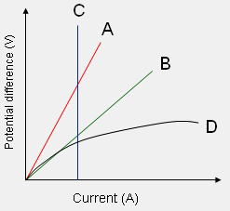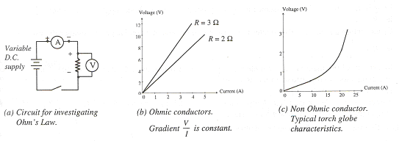These resistors are called **non-ohmic** **conductors** as the relationship between potential difference and current is not directly proportional and a curved line is obtained when graphing.

**NP p161-2 QS 5.5 p162**

**Questions**:

1. An electric stove element has a resistance of 12 Ω. If 240 V is applied across the element what is the current in it?
2. What is the potential difference across a 20.0 Ω resistor which is carrying a 4.00 A current?
3. A current of 1.00 x 102 mA flows through a resistor of 5.00 x 106 Ω. Calculate the potential difference across the resistor.

**Chap Review p169-70 EP p105 Problem Set 11 Expt 11.2 p 108**

Circuit analysis and design involve calculation of the potential difference across the current in, and the power supplied to, components in series, parallel, and series/parallel circuits

*This includes applying the relationships*





**NP p173**

**Experiments to further investigate Current, Resistance and Potential Difference**

**EXPERIMENT ONE**: **Current in a simple circuit with a 50 Ω resistor.**

Purpose: To compare the current (I) on either side of a known resistor in a simple circuit.

Predict how the current value, I1 , will compare to I2

Procedure:

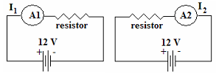Set up circuit with a 50 Ω resistor and take readings as indicated. Power pack is to be set on 12 V but you will need to take actual potential difference reading of power pack.

Results:

V =  V

I1 =  A I2 =  A

Calculation: *Ohm’s Law: V = IR*.

Using R and measured I, calculate V and compare to measured value of V.



**Repeat the experiment but use a 100 Ω resistor.**

Results:

V =  V

I1 =  A I2 =  A

Using the results of your experiments, what can you conclude about current in a simple circuit?

____________________________________________________________________________________________________________________________________________________________________________________________________________________________________

Explanation of results: *After class discussion, explain results in terms of theory of electricity.*

____________________________________________________________________________

____________________________________________________________________________________________________________________________________________________________________________________________________________________________________________________________________________________________________________________________________________________________________________________________________________________________________________________________________________________________________________________________________________________________________________________________________________________________________________________________________________________________________________

**EXPERIMENT TWO**:

**Current and potential difference in a series circuit with two resistors of same value**

Purpose: To compare the current and potential difference in different parts of the circuit with two resistors of same value (use two 50 Ω resistors)

Prediction:

* 1. Predict how A1, A2 and A3 will compare to each other.
  2. Predict how V1, V2 and VT will compare with each other.

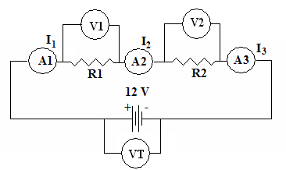

Procedure: Set up circuit and take readings*.*

Results: Resistor value: Ω

V1 = V V2 = V VT(total) = V

I1 = A I2 = A I3 = A

Calculations:

1. Using VT(total) and current, calculate total resistance.

1. How does this value compare to each of the resistors?
2. How do V1 and V2 compare to the total potential difference?

What conclusions can you make about current and potential difference in a series circuit?

____________________________________________________________________________________________________________________________________________________________________________________________________________________________________________________________________________________________________________________________________________________________________________________________

***QUESTIONS:*** *How does the current value change as additional resistors are added? Is there a mathematical relationship that you can see from your two experiments?*

________________________________________________________________________________________________________________________________________________________________________________________________________________________________________________________________________________________________________________

**Repeat the experiment but this time use two different resistors.**

**Current in a series circuit with two resistors of different value (50 Ω and 100 Ω)**

Purpose: To compare the current and potential difference in different parts of the circuit with two resistors of different values. R1 = 50Ω and R2 = 100 Ω

Predict how V1 will compare to V2 and then to VT

____________________________________________________________________________

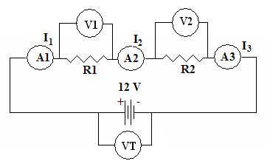Procedure: Set up circuit and read values indicated.

Results:

R1 = 50 Ω R2 = 100 Ω

I1 =  A I2 =  A I3 =  A

V1 =  V V2 =  V VT(total) =  V

Calculations:

1. Using VT(total) and current, calculate total resistance.

2. How does this value compare to each of the resistors?

3. How do V1 and V2 compare to the total potential difference?

What conclusions can you make about current and potential difference in a series circuit?

____________________________________________________________________________________________________________________________________________________________________________________________________________________________________________________________________________________________________________________________________________________________________________________________

Explanation of results: *After class discussion, explain results in terms of theory of electricity.*

____________________________________________________________________________________________________________________________________________________________________________________________________________________________________________________________________________________________________________________________________________________________________________________________

________________________________________________________________________________________________________________________________________________________________________________________________________________________________________________________________________________________________________________

**EXPERIMENT THREE**:

**Current and potential difference in a parallel circuit with two resistors of same value**

Purpose: To compare the current and potential difference in different parts of the circuit with two resistors of same value.

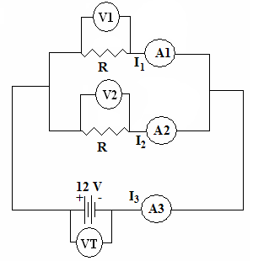

Predict how the values for A1, A2 and A3 will compare:

Predict how the values for V1, V2 and VT will compare:

Procedure: Set up circuit and read values indicated.

Results: R = Ω

I1 =  A I2 =  A I3 = A

V1 =  V V2 =  V VT =  V

**Repeat the experiment but this time use two different resistors.**

**Current in a parallel circuit with two resistors of different value (50 Ω and 100 Ω)**

Procedure: Set up circuit and read values indicated.

Results: R1 = Ω R2 Ω

I1 =  A I2 =  A I3 =  A

V1 =  V V2 =  V VT =  V

What conclusions can you make about current and potential difference in a parallel circuit?

____________________________________________________________________________________________________________________________________________________________________________________________________________________________________________________________________________________________________________________________________________________________________________________________

***QUESTION:*** *How does the current value change as additional resistors are added in parallel? Is there a mathematical relationship that you can see? Carry out an investigation and find out.*

Explanation of results: *After class discussion, explain results in terms of theory of electricity.*

____________________________________________________________________________________________________________________________________________________________________________________________________________________________________________________________________________________________________________________________________________________________________________________________

**Resistance, Current and PD in Circuits – The Theory**

1. **The Basics**

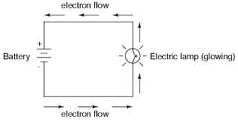

1. Electrons flow around the circuit from the energy source (power pack) back to the energy source – the rate of flow of electrons (or charge) is called ***current*** (symbol I) and is measured in ***amperes or Amps*** (symbol A).
2. Any part of the circuit that tries to slow the movement of the electrons (current) is called a resistor. This slowing is called ***resistance*** (symbol R) and is measured in ***ohms*** (symbol Ω).
3. The ***electric potential difference*** (symbol V) can be described as the work done per unit charge as a charge is moved between two points in an electric field. That is, V = W ÷ q, which we have already studied on page 15 of this workbook.

* Another way of looking at potential difference that can help in understanding the mathematical electrical circuits is that potential difference can be thought of as the energy given to the electrons by the energy source (power pack) that can be used to run electrical devices such as globes.
* The energy source is called an **emf** or electromotive force and although its units are volts, it is very different from potential difference (Year 12 work).

1. **Applying The Basics**
2. Electrons given energy by power pack to create a large charge difference (potential difference).
3. Electrons move around circuit at a certain rate (current)
4. When electrons come to a resistor (electrical device) they use energy (potential difference) to overcome resistance – that is, they do work.
5. Electrons then return to power pack for more energy.

**C. Series Circuits:**

* In a series circuit, there is only one path for the current.
* Cheap Christmas tree lights are a good example of this type of circuit and this type of circuit will not work if one of the parts (e.g. a globe) is broken as the path for the electrons to flow is broken.
* Remember that the globes resist the flow of electrons and cause electrons to bunch up (potential difference) so as more globes (resistors) are added, they all get dimmer and dimmer.
* This also results in less current flowing through the circuit (rate of flow of electrons) as there is more resistance as each globe is added to the circuit so harder for electrons to get around circuit.

# D. Parallel Circuits

* In a parallel circuit there is more than one path for the electrons to flow so if one part of the circuit is broken e.g. by a blown globe, the rest of the globes will stay on as the electrons still have a path to flow through.
* The sum of the currents in the different parts of a parallel circuit is equal to the total current of the circuit.
* The electrons carry the energy (potential difference) from the power pack and are able to go down different paths and light all the globes to the same brightness (each gets the same amount of current flow) as long as the globes have the same resistance.
* To keep globes at the same brightness, it means that more electrons are needed so the current required increases (increased flow to carry more energy) as more globes are added in parallel.
* This is also due to the decrease in resistance as there are more paths for electrons to flow.

**Mathematical Relationships in Circuits**

**Simple Circuits:** Ohm’s Law **= V = IR**

**Series Circuits:** Total Current = **IT = I1 = I2 = I3 = … = In**

Total Potential Difference = **VT = V1 + V2 + V3 + … + Vn**

Total Resistance = **RT = R1 + R2 + R3  + … + Rn**

**Parallel Circuits:** Total Current = **IT = I1 + I2 + I3 + … + In**

Total Potential Difference = **VT = V1 = V2 = V3 = … = Vn**

Total Resistance = 

**RT = (R1-1 + R2-1 + R3-1)-1**

**SIMPLE CIRCUIT:**

1. A 50.0 Ω resistor is placed in a simple circuit with a 12.0 V potential difference. What is the current in the circuit?

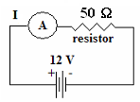

**SERIES CIRCUITS:**

1. Another 50.0 Ω resistor is added into the circuit above. What is the current now?

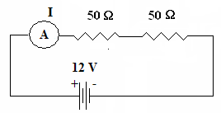

1. Calculate the potential difference for each resistor.

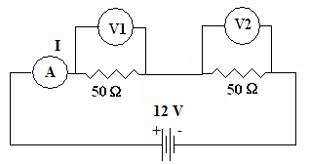

1. A 50.0 Ω resistor is placed in series with a 1.00 x 102 Ω resistor with a 12.0 V potential difference.

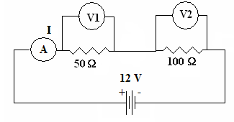

1. Find the current in the circuit.
2. Find the potential difference for each resistor.

**Note:**

**You can do this via proportions. You know that less resistance means less potential difference.**

**As R1 is half of R2, then half the PD. So for R1 (4.0 V) and for R2 (8.0 V)**

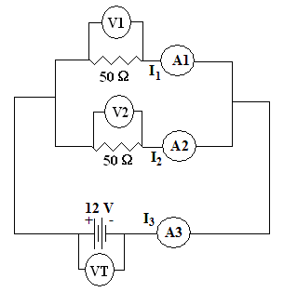

**NP p173-5**

**PARALLEL CIRCUITS**

1. Two 50.0 Ω resistors are placed in parallel. Find the current in each branch.
2. 50.0 Ω and a 100 Ω resistor are placed in parallel. Find the current in each branch.

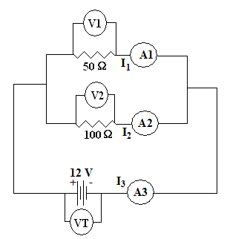

**NP p175-7**

**COMPLEX CIRCUITS**

Look at the circuit below then find the values on the meter shown.

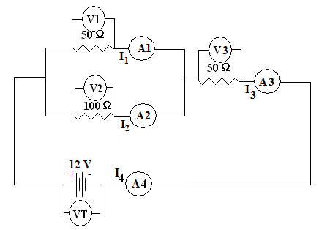

**ANSWER:**

**RT = 83.3 Ω**

**I1 = 0.096 A**

**I2 = 0.048 A**

**I3 = I4 = 0.144 A**

**V1 = V2 = 4.80 V**

**V3 = 7.20 V**

1. Look at the circuit below then find the values on the meters shown.

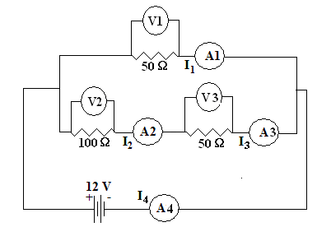

**ANSWERS:**

**RT = 37.5 Ω**

**I1 = 0.240 A**

**I2 = 0.0800 A**

**I3 = 0.0800 A**

**I4 = 0.320 A**

**V1 = 12.0 V**

**V2 = 8.00 V**

**V3 = 4.00 V**

**NP p179-81**

**Some More Circuit Problems for you to do yourself**

1. Find the readings on the two metres. (answer: V = 1.41V, A = 0.0706A)

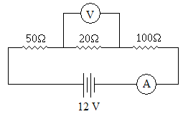

1. Find the readings on the two metres. (answer: A = 0.6A, V = 12V)

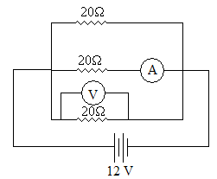

1. What is the value of R when A is 0.04A? (answer: R = 150 Ω)

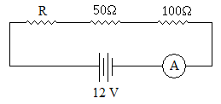

1. Find the value of R when A is 0.8A. (answer: R = 60Ω)

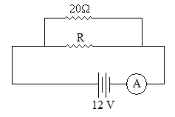

1. Find the readings on the metres. (Answer: V = 2.4V, A = 0.096A)

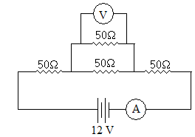

1. Find the reading on the ammeter. (answer: A = 0.48A)

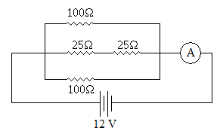

1. 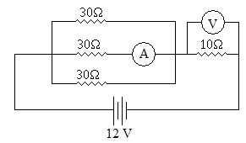Find the reading on the metres. (Answer: V = 6V, A = 0.2A)

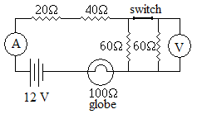

1. Look at the circuit below. If the switch is opened, will the light stay the same brightness, get dimmer or get brighter? Explain. (HINT: you might like to work out the total current in each case.)

**NP QS 6.1 p182 EP p115 Problem Set 12**

**WSG 3.2 p69-76**

There is an inherent danger involved with the use of electricity that can be reduced by using various safety devices, including fuses, residual current devices (RCD), circuit breakers, earth wires and double insulation

**OPERATING PRINCIPLES OF COMMONLY ENCOUNTERED ELECTRICAL DEVICES**

* All mains electrical circuits have the following in common:
* a source of emf - the mains supply usually 240 V A.C.
* a form of protection - e.g. a fuse
* a form of control - e.g. a switch
* a load, which converts electrical energy to some other form of energy e.g. motor
* low-resistance cables to join the parts together.

**House Wiring**

* 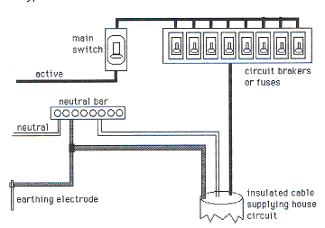The electricity is brought from the pole station to your home via two wires.
* One of these is the **active wire** and the other is the **neutral** wire.
* The active wire passes the current through a switchboard which holds a mains switch, a meter and circuit breakers that protect the various distribution circuits within the house.
* The neutral wire is connected to the neutral bar.
* Each appliance has a neutral wire which is also connected to the neutral bar.
* The neutral bar is in turn connected to the earthing electrode giving the neutral wire and earth wires zero potential to the earth.
* It is the active wire that carries the 240 V potential difference which operates the electrical appliances and is the potentially dangerous wire.
* The neutral wire is connected to the ground or earth.
* While the neutral wire should theoretically be safe to touch as it should have zero potential, never assume this is so as there could be a short circuit or incorrect wiring that makes it ‘live’.
* The diagram shows a typical switchboard.
* As all power outlets and lights must deliver mains voltage independently to each appliance, they are connected in **parallel,** each power outlet having its own fuse for protection. Fuses and switches are in series.
* The diagram shows a typical fuse in a circuit for lights in a house and the way the wires are placed.

**Questions to think about:**

* 1. Why are parallel circuits mainly used in homes and not series circuits which can be found in switches?
  2. In which wire should you place switches, the active or the neutral? Why?
  3. Why is it dangerous to “piggy-back” double adaptors on top of each other? What is the alternative?

**Two Way Switches.**

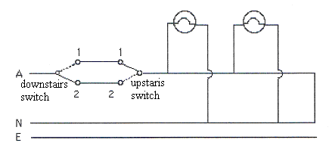

* Sometimes, a light needs to be controlled from two locations; for example, a hallway may be lit by a light switched from either ends.
* An example of the circuit for this type of lighting is shown:

**Dimmer Switches (Rheostat)**

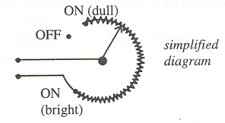

* The brightness of lights can be varied by using a switch which incorporates electronic components such that it acts somewhat like a variable resistor.

**NP p197-8**

**ELECTRICAL SAFETY**

* Mains supply presents a potential hazard to life, since a relatively small current passing through the human body can be deadly.
* Anyone using electricity should be aware of the dangers associated with it and electrical installations should only be carried out by qualified electricians.
* People are injured or die every year because of carelessness, negligence or sheer bad luck.
* With care and common sense, many of these unfortunate incidents could be avoided.

**Power Circuits**

* Power points are on a separate circuit of their own and are also wired in parallel.
* This allows full mains voltage (240 V) to each power point.
* 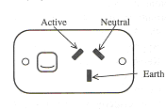The previous (old) and international (new) colour codes for wiring are:

|  |  |  |
| --- | --- | --- |
| **Wire** | **Previous (old)** | **International (new)** |
| Active | Red | Brown |
| Neutral | Black | Blue |
| Earth | Green | Green/Yellow |

**Electrical Shock**

Voltages as low as 32 A.C. or 115 D.C. can be dangerous.

|  |  |
| --- | --- |
| **CURRENT (mA)** | **EFFECTS ON THE BODY** |
| 1 | Able to be felt |
| 3 | Easily felt |
| 10 | Painful |
| 20 | Muscles paralysed — cannot let go |
| 50 | Severe shock |
| 90 | Breathing upset |
| 150 | Breathing very difficult |
| 200 | Death likely |
| 500 | Serious burning, breathing stops, death inevitable |

*Table of the Effect of mains electricity on the human body*. (240 V, 50 Hz, AC, 0.5 5)

* Quite small currents flowing from one side of the body to the other can be dangerous, depending on the time for which they flow.

|  |  |  |
| --- | --- | --- |
| **CURRENT (mA)** | **TIME OF CURRENT**  **(ms)** | **EFFECTS ON THE BODY** |
| 50 50 50 | 10 - 200  200 - 4000  > 4000 | Usually no dangerous effects Shock Severe shock |

* The most dangerous path for current is from one limb to another, across the chest, since this is most likely to affect the heart.
* The lower the resistance to current flow, the greater the current that will pass through the body and the greater the danger to life.
* Skin resistance is lower when the skin is wet, or broken by a cut or abrasion, so situations should be avoided in which electricity and water are in close proximity.
* There are several features of a mains installation which contribute to safety:
* fuses and circuit-breakers,
* residual current device (RCD) and earth leakage circuit breaker (ELCB)
* earthing and double insulation.

**Fuses and Circuit-Breakers**

* Faults in electrical circuits can cause short circuits causing large amounts of current to flow and produce overheating and possibly a fire.
* To guard against this, fuses (thin wires) are wired in series with the active wire.
* If an excessive current flows, the fuse melts and disconnects the active wire. Once the fault is rectified, a new fuse is connected and the current can again flow.

**Residual Current Device, RCD**

* All new houses now use circuit-breakers instead of fuses (required by law since 2000).
* A circuit-breaker is an electromagnet switch which automatically turns off when an abnormally high current flows. It is reset once the fault is corrected.
* Examples are RCD, RCCB and ELCB.
* A **residual current device** (**RCD**), similar to a **residual current circuit breaker** (**RCCB**), is an [electrical wiring](http://en.wikipedia.org/wiki/Electrical_wiring) device that disconnects a circuit whenever it detects that the [electric current](http://en.wikipedia.org/wiki/Electric_current) is not balanced between the energized conductor and the return [neutral](http://en.wikipedia.org/wiki/Ground_and_neutral) conductor.
* Such an imbalance is sometimes caused by current leakage through the body of a person who is grounded and accidentally touching the energized part of the circuit.
* A [lethal](http://en.wikipedia.org/wiki/Lethal) [shock](http://en.wikipedia.org/wiki/Electric_shock) can result from these conditions. RCDs are designed to [disconnect](http://en.wikipedia.org/wiki/Open_circuit) quickly enough to mitigate the harm caused by such shocks although they are not intended to provide protection against overload or [short-circuit](http://en.wikipedia.org/wiki/Short-circuit) conditions.
* An **Earth Leakage Circuit Breaker** (**ELCB**) is a safety device used in electrical installations with high [earth impedance](http://en.wikipedia.org/wiki/Earthing_system) to prevent shock.
* If a person touches something, typically a metal part on faulty electrical equipment, which is at a significant voltage relative to the earth, electrical current will flow through him or her to the earth.
* The current that flows is too small to trip an electrical fuse which could disconnect the electricity supply, but can be enough to kill. An ELCB detects even a small current to earth (Earth Leakage) and disconnects the equipment (Circuit Breaker).

**Earthing and Double Insulation**

* As many appliances have metal parts, it is possible for a fault to occur which brings the active wire in contact with the metal, leading to an electric shock.
* Because of this all metal parts in an appliance are earthed so that if the metal becomes ‘live’ the current will flow harmlessly into the ground (via the earth wire), instead of through the user.
* 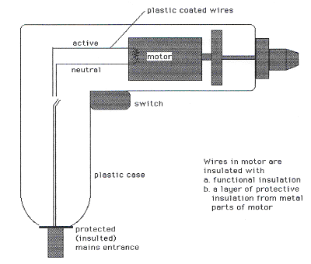If an appliance is not earthed, it is double-insulated. Double-insulation isolates the live parts of the circuit from the user by interposing two separate layers of insulation between the live parts and any external metal.
* Both sets of insulation would have to break down to create a hazard. Although this provides a high degree of safety, it is still possible for both sets of insulation to be bypassed; for example, by wetting a drill accidentally with a hose while someone is using it.
* The double-insulated drill has the wires in the motor insulted with functional insulation and protective insulation.
* Attempting to earth such an appliance can actually damage one of the electrically insulating layers, making it *less* safe rather than *more* safe.
* A further precaution with double-insulation is to place a **core-balance unit** between the mains power and the equipment.
* This unit compares the neutral and active current and automatically trips and turns the power off if there is an imbalance (which indicates leaking from the equipment to the earth).
* Many modern appliances including some hair-dryers, lamps, radios and clocks, are designed in such a way that no metal parts are accessible to the user.
* They are known as “all-insulated equipment”.

***THINK ABOUT THIS***

Explain why retrieving a double insulated hair-dryer (which is switched on) from a basin of water could result in a possibly fatal electric shock.

**Take care!**

* Although electricity is very useful, our mains supply presents a potential hazard to life as well as the possibility of fire.
* Quite small currents through the human body can cause severe shock or even death. As discussed before, a current of 500 mA would be fatal.
* Appropriate care should be taken at all times when using electricity.
* Remember that only a licensed electrician may carry out wiring alterations and electrical repairs. This also applies to plugs and extension leads. A common cause of electrical accidents is due to incorrectly wired plugs and power leads.
* If a fuse blows the cause of the fault should be checked and rectified. Simply using a higher rated fuse may cause a more serious situation.

**Questions:**

1. You can receive 60 000 V from a van der Graaff Generator and be unharmed, however if you receive 240 V from the mains, it can kill you. Explain why?
2. Some appliances don’t have an earth, rather they are “double insulated”. Explain what this is and how it replaces the earth wire.
3. What is a fuse and how do they work?
4. Today, most new homes use a circuit-breaker rather than a fuse. Explain how a circuit-breaker works.
5. Consider the following situation then answer the questions.

*Your neighbour has touched a faulty appliance and suffered an electric shock. A heart attack has resulted, causing his breathing to stop. You are called in to assist. You find your neighbour unconscious on the ground. The electrical appliance he was using can’t be seen. He may still be in contact with it and so you need to move him away.*

1. Why is it sensible to use a broom handle to push your neighbour away and not your bare hands?
2. Why would you be wise to stand on newspaper while doing this?
3. Suggest some other steps you might take before touching him, remember, time is important.
4. Once your neighbour is no longer in contact with the appliance, suggest what should immediately be done for him.

**NP 198-9 QS 6.4 p200 Chap review p201-3 EP p125-6 Problem Set 13**

**WSG p77-8 Q’s 9-28 p79-81**

Electrical circuits enable electrical energy to be transferred and transformed into a range of other useful forms of energy, including thermal and kinetic energy, and light

* The purpose of an electrical circuit is transfer electrical energy (electrons) from a power source to an appliance.
* The appliance can then transform the electrical energy into a more useful form, such as heat (thermal energy), movement (kinetic energy) or light.

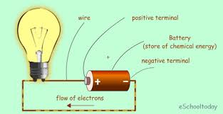

**Set 14: Electrical Charges and Fields**

14.1 Sketch the electric field distribution in the following cases:

[a] around an isolated small negatively charged sphere;

[b] between a small negatively charged sphere and a small positively charged sphere;

[c] between two small positively charged spheres;

[d] between a small positively charged sphere and an earthed conducting plate.

**See notes**

14.2 On a dry day people may get small electric shocks as they enter or leave a car.

Use your knowledge of static electricity to account for this effect.

**Key idea is that the charge is caused by friction between the person’s clothes and the sea covering material. Tyres are insulating the car from the ground.**

14.3 Two dust particles being drawn up into a vacuum cleaner collide, causing 1000 electrons to transfer from one particle to the other.

[a] Calculate the magnitude of the electric charge that each dust particle has now acquired.

**q = 1000 x 1.6 x 10-19**

**= 1.6 x 10-16 so one is +1.6 x 10-16 C and one is -1.6 x 10-19 C**

[b] After collision, the particles separate so they are 0.010 mm apart. Calculate the magnitude of the electric force between the particles, and state whether this will lead to attraction or repulsion between the particles.

**F = **

**F = -2.304 x 10-18 N**

**F = 2.30 x 10-18 N attraction**

[c] Draw a diagram showing the nature of the electric field in the space around the particles.

**Draw field lines between two oppositely charged spheres.**

14.4 A certain semiconductor chip in a computer stores one bit of data by retaining a charge of 0.7 pC. A cosmic ray hits the chip releasing the equivalent of 7 x 106 electrons in the semiconductor material. Can such a random event lead to a computer error? Explain.

**Given: charge retained q = 0.7 pC or 0.7 x 10-12 C**

**Number of electrons released = 7 x 106**

**q (electrons) = 7 x 106 x 1.6 x 10-19**

**= 1.12 x 10-12 C**

**Therefore the random event can lead to a computer error as the cosmic ray releases more charge than is required to store data.**

14.5 'L plates' for learner drivers are often made of a flexible plastic. If you rub the plastic on some clothing it then sticks to the windows of the car.

[a] What effect does rubbing have on the charges in the plastic?

[b] Why does the plastic L plate stay on the window?

[c] Explain which types of surfaces the L plate would not stick to.

[d] Is there an even distribution of charge on the L plate? Why, or why not?

**a. Electrostatic attraction due to opposite charges being on the L plate and the window**

**b. Friction, rubbing of L plate on clothing**

**c. Metallic surfaces, since cannot charge permanently a metal surface.**

**d. Yes. Charge would move if there was an unequal distribution.**

14.6 On a dry day the movement of a charge of 2.0 x 10-9 C between your hair and your comb causes a spark. The spark lasts for 1.0 μs. What is the magnitude of the current that flows in this case?

**q = 2.00 x 10-9 C **

**t = 1.0 x 10-6**

**I = 2.00 x 10-3 A (3 sf)**

14.7 A service station charged a car battery for four hours, using a current of2 A. Calculate:

[a] how much charge passed through the battery during that time;

**Charge = I . t [s]**

**= 2 x 4 x 60 x 60**

**= 28 800 Coulombs**

**q = 2.88 x 10 4 C**

[b] how many electrons passed through the battery during that time.

**Electrons = q/1.6 x 10-19 = **

**= 1.8 x 1023 electrons**

14.8 An electric toaster operated for 90 seconds with a current of 4.0 A.

[a] Calculate the total charge that passed through the toaster element.

**q = It**

**= 4 x 90**

**q = 360 C**

[b] If the potential difference across the toaster element was 240 V, calculate the amount of energy released by the toaster element.

**W = qV (don’t forget work is energy)**

**= 360 x 240**

**W = 86400 J**

**W = 8.64 x 104 J**

14.9 Max was on coffee duty at church, and had to put out, as close together as possible, 150 empty polystyrene cups to be filled later. They were initially stacked 25 high in cartons. Suggest a reason why Max found it difficult to set them out so they stayed stable.

**When taking the coffee cups out of the stacks in the carton you charge them electrically. Since polystyrene is an insulator the charge is retained and since they are set out close together there is a coulombic force between them. Whether this is attraction or repulsion makes no difference!**

14.10 Nic finds that his clothes are clinging together when he removes them from a clothes drier. This results from the static charges in the clothes that built up during drying. Nic needs to exert a force of 0.5 N to pull apart two articles of clothing.

[a] Assuming that the charges are equal in magnitude and that the distance between the two articles is 0.8 mm, estimate the charge on each.



**q2 = 3.6 x 10-17 C**

**q = 6.0 x 10-9 C**

[b] Explain why this calculation must be an estimate.

14.11 Millikan's oil-drop experimentcan be used to determine the charge on an electron. A charged oil drop is suspended between two parallel charged plates, separated by 2 cm of vacuum as shown. The force of attraction between the oil drop and the top plate is exactly balanced by the weight force acting downwards.

[a] What **sign of charge** must the oil drop in the above diagram have?

**Must be negative so as to be attracted to the top positive plate**

[b] If the gravitational force on the oil drop is 2 x 10-3 N, state the magnitude of the electrostatic force that must be acting on the drop.

**To be in equilibrium the forces must be equal and opposite. Magnitude will be 2 x10-3 N ,**

[c] Predict what would happen if the charge on the oil drop was doubled, if all other variables remain unchanged.

**Oil drop would "rise" and travel towards the top plate.**

[d] If the charge on the oil drop was found to be 6.4 x 10-18 C, how many electron charge units are on the oil drop?

**6.4 x 10-18  = 40 electron charge units**

**1.6 x 10-19**

[e] If another oil drop, carrying the same charge as in [d] was then injected at B as shown in the diagram, what would be the force exerted on it due to the original oil drop? They both have the same charge as in [d].

**F = k.q1q2**

**r 2**

**F = 9 x 10 9 [6.4 x 10 -18] 2 = 9.21 x 10-22  N**

**[ 2x10-2 ] 2**

[f] Suggest a way by which an oil drop could be initially charged.

**Any suggestion that involves friction charging the oil drop as it enters the gap between the plates.**

14.12 Lightning is a natural phenomenon involving huge potential differences and currents. For spark to flow through humid air, an electric field of the order of 106 V m-1 is required.

[ a] Identify the physical principles involved and estimate the potential difference between the ends of a typical lightning strike.

[b] How is this enormous potential difference produced?

It has been estimated that the energy in a lightning bolt is enough to light a 100 W globe for three months.

[c] Calculate the quantity of energy involved in such a lightning bolt. [d] Using your calculated value from [c] and your estimated potential difference from [a], what charge must be generated in the clouds?

[e] Assuming that the lightning bolt lasts for 50 microseconds, what current must flow between the clouds and the Earth?

**a. Current follows the path of “least resistance" and that is to a conductor on the ground. The air is ionised and the spark/ ionised flash represents that current path. Air, even humid air, is not a good conductor of electricity! Typical values: the electric field for a spark is of the order of 106 V/m so the difference in voltage between the ends would be of the order of 10 9 Volts.**

**b. Cause is friction of clouds with the air. To calculate the current you would need to first find the resistance by using the resistivity of humid air and the cross sectional area of the lightning bolt.**

**c. 100 W for 3 months = 100 x 60 x 60 x 24 x 30 x 3 = 8 x 10 8  Joules**

**d. W = q V**

**8 x 10 8 = q x 10 9**

**q = 1 coulomb**

**e. q = It**

**t = 50 x 10 –6 s q = 50 x 10-6 x 20 000**

**I = 20 000 amps q = 1.00 C**

**Set 15: Electrical Energy and Power**

15.1 A 1200 W toaster is connected to the 240 V electrical mains.

[a] Calculate the current drawn by the toaster element as it operates.

**P = 1 200 W P = VI**

**V = 240 V 1200 = 240 x I**

**I = ? I = 5.0 A**

[b] Calculate the resistance of the toaster heating element.



**R = 48 Ω**

15.2 A 6 W globe draws a current of 500 mA when operating normally.

[a] Calculate potential difference across the light globe filament as it operates.

**P = VI**

**6 = V x 0.5**

**V = 12 V**

[b] Calculate the resistance of the light globe filament.

**V = IR**

**12 = 0.5 x R**

**R = 24 Ω**

15.3 Calculate the operating resistance of a 100 W electric mixer motor when you connect it to a 240 V mains supply.

**P = VI and I = V/R**



**R = 576 Ω**

15.4 The rear window demister of a car draws 2.0 A of current from the 12 V car battery and takes 20 minutes to demist the window.

[a] Calculate the quantity of electric energy that is converted into heat energy in that time.

[b] What is the power rating of the demister?

[c] How much charge flows in the 20 minute period?

**(a) Electrical Energy = W = VIt**

**= 12 x 2 x (20 x 60)**

**= 2.88 x 104 J**

**(b) P = I.V**

**P = 2 x 12**

**= 24 W**

**(c) q = I t**

**= 2 x (20 x 60)**

**q = 2.4 x 103 C**

15.5 A small light globe is marked 17 mA, 4 W.

[a] Is it a household lamp or for a car? What is the evidence for your answer?

**P = VI**

**4 = V x 17 x 10-3**

**V = 234 V**

**So most likely a household lamp running on 240 V**

[b] What is the operating resistance of the globe?

**V = IR**

**234 = 17 x 10-3 x R**

**R = 1.38 x 104 Ω**

15.6 The motor from a toy is marked 380 mA, 2.3 W.

[ a] What voltage of power supply is it designed for? What is the evidence for your answer?

**P = VI**

**2.3 = V x 0.38**

**V = 6.05 V**

[b] What is the operating resistance of the motor?

**V = IR**

**6.05 = 0.38 x R**

**R = 15.9 Ω**

15.7 A typical headlight globe in a car operates at 12 V and dissipates 55 W of heat and light.

[a] Calculate the current passing through the globe filament under normal operating conditions.

**P = VI**

**55 = 12 x I**

**I = 4.58 A**

[b] Calculate the resistance of the globe under normal operating conditions.

**V = IR**

**12 = 4.58 x R**

**R = 2.62 Ω**

15.8 The unit by which electrical energy is sold and paid for is called the kilowatt-hour (kW h). The electricity bill delivered to your house is for the number of kW h of electricity you have used multiplied by the price of one kW h. The price is currently around 13c per kW h. Calculate how much it costs to operate the following devices at home:

[a] A 60 W desk lamp for 3.0 hours per day, 5.0 days per week, for 9.0 weeks.

** x 3 x 5 x 9 x 0.13 = $1.05**

[b] An 11 W fluorescent' energy saver lamp' in the same light fitting as part [ a] of this question for the same number of hours.

** x 3 x 5 x 0.13 = $0.19**

[c] A 2400 W fan heater for four hours.

** x 4 x 0.13 = $1.25**

[d] A 1700 W electric kettle for the five minutes it takes to boil water to make tea.

** x (5 ÷ 60) x 0.13 = 1.8 cents**

15.9 Calculate the cost of running each of the following from the 240 V mains:

[a] an electric fan heater rated at 2 kW, for 3 hours;

[b] an electric water heater whose element has a resistance of 26 Ω, for 4 hours;

[c] an electric drill rated at 8 A, which is run for 30 minutes.

**a . Cost = number of kWh . 13 cents**

**= 2 x 3 x 13 = 78 cents**

**b. Power = **

**Cost = Power in kW x time [ hours] x (13 cents) =  x time x 0.13**

**= 2402 x 4 x 0.13**

**24 x 1000**

**= $ 1.25**

**c. Cost = Power in kW x time [ hours] x (13 cents)**

**= (I V x time x 13 cents) ÷ 1000**

**= 8 x 240 x 0.5 x 0.13 = $0.125**

**1000**

15.10 Estimate the cost of electric lighting in your house for one year. You will need to list the power ratings of all the globes and fluorescent tubes, and estimate the times for which they operate in one year.

15.11 You fit a 150 W floodlight lamp globe in a 240 V outlet in preparation for a party.

[a] Calculate the current in the filament when the lamp is operating normally.

**P = VI**

**150 = 240 x I**

**I = 0.625 A**

[b] What is the lamp's resistance?

V = IR

240 = 0.625 x R

R = 384 Ω

[c] If it converts 95% of the electrical energy used into heat, how many joules of light energy will it produce in 1.0 h?

**95% of electrical energy converted to heat therefore only 5% of electrical energy is converted to light.**

**E light = E electrical**

**= 0.05 x VIt**

**= 0.05 x 240 x 0.625 x 60 x 60**

**= 27000 J**

**= 2.70 x 104 J**

[d] Calculate the cost of leaving the light on for 5 hours, at a cost of 13 cents per kilowatt-hour.

**Cost =  x 5 x 0.13**

**= 9.75 cents**

15.12 If it costs $800 to insulate the roof of a small apartment, with the result that the 4000 W air conditioner, when needed, is operated for an average of three hours less per day:

[a] calculate how many days' use it will take for the electrical savings to cover the cost of the insulation;

[b] hence estimate how long it will take (in weeks, months or years) for the electrical savings to cover the cost of the insulation.

15.13 Batteries are given a form of energy rating - the 'amp-hour'. It is not really an energy rating but when multiplied by the emf of the battery it tells us how much energy can be obtained from the battery before it is 'flat'. For example, a battery might be rated at 10 amp-hours. This means that it can deliver 2 A for 5 hours, or l A for 10 hours, before its emf drops to a useless level.

[a] A standard 12 V car battery is rated at 40 amp-hour. How much energy, in joules, can it provide before it is 'flat'?

[b] A more expensive 12 V battery is rated at 75 amp-hour. For how long can it be used for emergency lighting comprising of two 55 W headlight globes?

15.14 A nickel metal hydride rechargeable AA cell is rated at 2.3 amp-hour and has an emf of approximately 1.4 V when fully charged. Suppose one such cell

is used in a small 3 W 'key light'. How long will the cell last until it needs to be recharged?

**Set 16: circuits and Ohm’s law**

16.1 Kylie measures the potential difference and current in a circuit.

[a] The potential difference across a resistor is 2.55 V when the current through the resistor is 120 mA. Calculate the resistance of this component.

**V = IR**

**2.55 = 0.12 x R**

**R = 21.3 Ω**

[b] A resistor is marked as 147 kΩ and has 3.42 V across it. Calculate the current through this resistor.

**V = IR**

**3.42 = I x 147 000**

**I = 2.33 x 10-5 A**

[c] A 2.0 kΩ resistor has a power rating of 1.6 W. Calculate the maximum current it will tolerate.

**P = IR**

**1.6 = I x 2000**

**I = 8.0 x 104 A**

16.2 A telephone receiver has a resistance of 8.0 x 103 Q, and it uses a current of 7.0 mA. What potential difference must the exchange supply to make the receiver work properly?

**V=IR**

**= 7.0 x 10-3 (8.0 x 103 )**

**= 56 V**

16.3 A technician has to replace the indicator lights in a stereo amplifier. Each light operates on 14.0 V and draws a current of 500 mA. Calculate the resistance of such a light.

**V = IR**

**R =14.0 / 500 x 10-3**

**= 28 Ω**

16.4 Your nephew, Tom, finds a toy car, but the battery is missing. You read the label on the car's motor. It states the motor uses 320 mA and has a resistance of 4.7 Ω. What potential difference battery would you advise Tom to use in his car?

**V = IR**

**= 320 x 10-3 x 4.70**

**= 1.504 V**

**1.5 V battery**

16.5 The resistance of metals increases as the temperature of the metal increases.

[a] Does the current through the metal element of a bar heater increase or decrease as the element heats up? Explain your reasoning.

**Ohm’s Law describes the relationship between current and resistance as inversely proportional. That is if the current increases the resistance decreases. The current of the bar heater must decrease as the bar becomes hotter.**

[b] What happens inside the heating element that causes the resistance to increase as its temperature rises?

**The atoms of the bar heater are moving more rapidly due to the increase in heat energy. This means the electrons will have their motion impeded and will not be able to move as fast. As current is the rate at which charge move, slower electrons would result in a slower current.**

[c] Calculate the resistance of a 240 V bar heater that passes l0 A once it is at its normal operating temperature.

**V = IR**

**240 = 10 x R R = 24 Ω**

[d] Calculate the power consumption of the a 240 V heater that passes l0 A at its normal operating temperature.

**P = VI**

**= 240 x 10 = 2400 W**

[e] During a 'brown-out' the electricity supply to your house might drop to 170 V. How will this affect the resistance and power consumption of the heater?

**If only 170 V then resistance decreases to 17 Ω as well as the power decreasing to 1700 W**

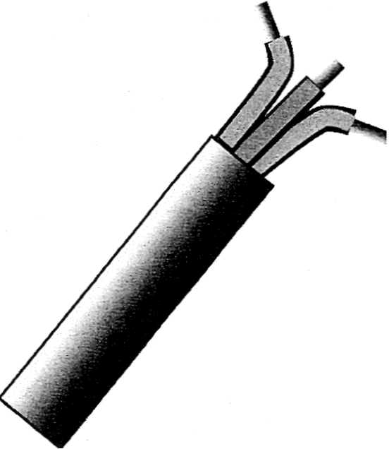16.6 The figureshows a three-core general-purpose domestic electrical cable, which electricians use in electrical wiring in a house. The manufacturers design the cable for use with 240 V, but it is still safe at 415 V. The standard for such a cable states that one kilometre of any of the three conductors must have a resistance of not more than 18.1 Ω at 20 0C.

[ a] Calculate the maximum resistance of one of the conductors in the cable if it runs 36.0 m from the meter board to a power outlet in a house.

**Maximum resistance = **

**= 0.65 Ω**

[b] Calculate potential difference that has to be applied across 36.0 m of this cable to maintain a current of 1.00 A through it.

**V = IR**

**= 1.00 x 0.65**

**= 0.65 V**

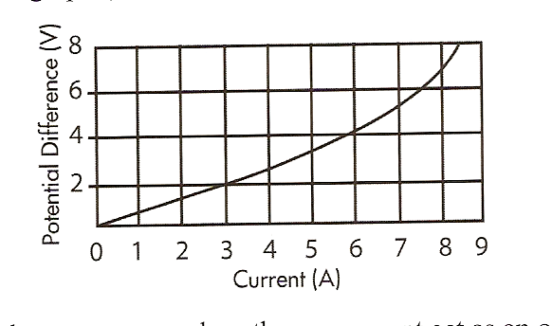 16.7 In an experiment on electrical circuits, the technician represented the data collected in the graph*.*

[a] Over which current range does the component act as an ohmic conductor?

[b] Calculate the resistance of the component in the ohmic region.

[c] Explain what happens to the resistance of the component at higher currents.

[d] What could cause such a change in resistance?

**a    Zero to 6 A**

**b    R = gradient = 4 / 6 = 0.67 Ω**

**c    resistance increases (gradient increases)**

**d The component increases its temperature as the current increases.**

16.8 Why is it that the electricity does not kill birds when they perch on high

voltage transmission lines?

**Bird on wire is much like a parallel circuit.**

**The resistance of the wire between the birds feet is much lower than the resistance of the bird’s body. As the potential difference is the same, the current flowing through the birds is insignificant compared to the current through the wire.**

16.9 A lie detector measures the sweat rate of subjects by detecting changes in their

skin resistance. Persons under stress normally produce more sweat, so lie-detector operators assume subjects will sweat more when they tell lies.

[ a] Would a lie detector register increased or decreased skin resistance as a typical subject starts to tell a lie? Explain why you chose your answer.

**Decrease in skin resistance. Sweat contains a high concentration of salts and so has a high**

**concentration of ions (charged particles), which conduct electricity in solutions**

[b] The detector shows this change in resistance as a needle movement, which traces a line on paper. What would this resistance change cause to happen to the current driving the needle motor?

**Since V is constant and the resistance has decreased the current must increase if Ohm’s law is correct.**

[c] If the potential difference across the detector is 12 V and the current through the detector is 35 mA, what is the resistance of the person's skin?

**V=IR**

**R= 12 / 35 x 10-3**

**= 343 Ω**

**Set 17: Parallel and Series Circuits**

17.1 Are the appliances in your home connected to the electricity supply in series or in parallel? Give evidence to support your answer.

**The appliances are connected in parallel with each other but in series with a RCD (residual current detector) or a fuse. If one device blows the others keep working (a property of parallel circuits), and if the circuit protector goes all the appliances do not work (a property of series circuits).**

17.2 Calculate the total resistance of a string of twelve fairy lights connected in series, if the resistance of each lamp is 30 Ω.

**Rt = 12 x R**

**= 12 x 30**

**= 360 Ω**

17.3 An auto electrician connects two 12 V car batteries in series.

[a] What is the total potential difference provided by this combination?

[b] She now connects three sidelights in series with the two batteries.

Each sidelight has an operating resistance of 20 ohms. What current will flow through each light?

[c] If she connects the sidelights in parallel instead of in series, calculate the total resistance of the three sidelights.

[d] How does the intensity of light in [c ] compare with [b]?

**a    VT = V1 + V2**

**= 12 + 12**

**= 24V**

**b    Rt = 3 x R**

**=3 x 20**

**= 60 Ω**

**V = I R**

**I = 24 / 60**

**= 0.4 A**

**c    1 = 1 + 1 + 1**

**Rt R1 R2 R3**

**= 1/20 + 1/20 + 1/20**

**= 0.15**

**Rt = 6.67 Ω**

**d    The intensity of light in (c) is greater than (b)**

17.4 A farmer wants to run a 12 V car radio on the 32 V farm electricity supply. The radio uses 4.0 A. What resistance must the farmer use in series with her radio?

**Voltage drop across resistor is 32- 12 = 20V**

**V = I R**

**R = 20 / 4**

**= 5 Ω**

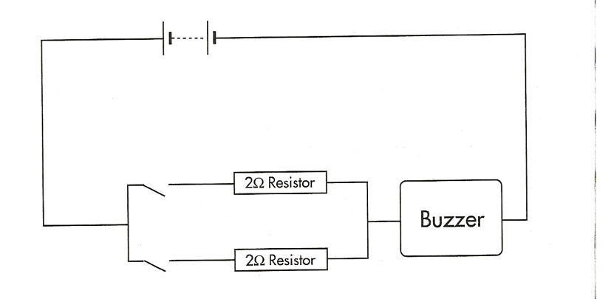17.5 Claire has a personal alarm with her for safety. It consists of two 9 V batteries, two switches each connected to a 2 Ω resistor and a buzzer of resistance 3 Ω. The circuit diagram is shown below:

[a] Calculate the total resistance of the personal alarm circuit when both of the switches are closed.

[b] Calculate the current passing through the buzzer when both of the switches are closed.

[c] The buzzer is louder when it carries a larger current. Which arrangement of switches (e.g. both closed, both open, one closed and one open) would result in the buzzer sounding the loudest? Explain your answer.

[d] Claire is concerned that the batteries might' go flat'. Calculate the energy consumed if the buzzer is left on for 3 minutes at the **softest** setting.

**a. 1 = 1 + 1**

**RT R1 R2**

**R total  = [1/2 +1/2 ]-1 + 3**

**= 4 Ω**

1. **V = I R**

**18 = I x 4**

**I = 4.5 Amps**

**c. Both switches closed because this would result in a parallel circuit so the overall resistance would be less so the current would be greater and so a louder buzzer.**

**d. If one switch open then total resistance is 5 Ohms, current is 18 = 3.6 A**

**5**

**Energy = Power . Time**

**= I.V . time [ s]**

**= 3.6 x 18 x 3 x60**

**= 1.16 x 10 4 J**

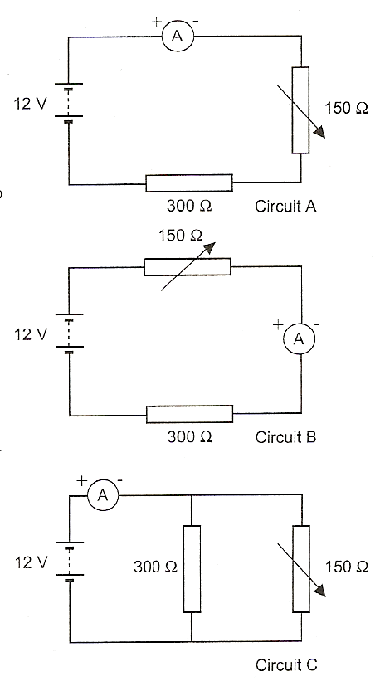

17.6 Heath, Jenni and Shani's teacher sets them a practical test. Each student has a tray containing a 150 Ω rheostat, a 300 Ω resistor, a 12 V power supply, a 2.00 Ω ammeter, and enough wires to connect any circuit. They have to connect a circuit that lets the rheostat control the greatest possible range of current through the apparatus.

[a] Heath builds circuit A. What is the least and greatest current he can achieve?

**V = I R V = I R**

**I =12 /452 I =12 /302**

**= 2.65 x 10-2 A = 3.97 x 10-2 A**

[b] Jenni builds circuit B. What is the least and greatest current she can achieve?

**V = I R V = I R**

**I =12 /452 I =12 / 302**

**= 2.65 x 10-2 A = 3.97 x 10-2 A**

[c] Shani builds circuit C. What is the least and greatest current she can achieve?

R = (300-1 + 150-1)-1 + 2 = 102 Ω

**V = I R V = I R**

**I =12 /102 I =12 /2**

**= 0.118 A = 6.0 A**

[d] Which circuit (A, B or C) gave the greatest range of current?

**Circuit C**

17.7 A client describes for you a circuit over the phone. 'A six ohm resistor is in series with a parallel combination of a ten ohm resistor and a fifteen ohm resistor. The whole three-resistor combination connects across a six volt supply. A voltmeter measures the potential difference across the smallest resistor and an ammeter measures the current through the largest resistor.'

[a] Draw the circuit.

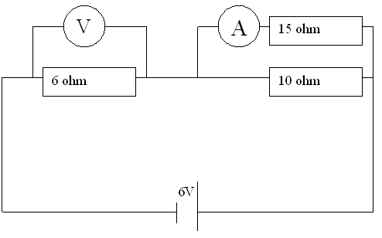

[b] What readings should the voltmeter give?

**1 = 1 + 1 ………..**

**Rt R1 R2**

**1/Rt = (1/10 + 1/15)**

**= 6 Ω**

**Rt = R1 + R2 ……**

**= 6 + 6**

**= 12 Ω**

**VT = IR**

**I =6 / 12**

**= 0.5 A**

**V6Ω = 0.5 x 6**

**= 3V**

[c] What readings should the ammeter give?

**V15Ω = 3V**

**I15Ω = 3 / 15**

**= 0.2 A**

17.8 A technician connects three resistors of 4.0 Ω, 8.0 Ω and 40.0 Ω in parallel. He measures that the 4.0 Ω resistor carries a 2.0 A current. Calculate:

[a] the combined resistance of the three resistances.

**1 = 1 + 1 ………**

**R R1 R2**

**1/Rt =(1/4 + 1/8 + 1/40)**

**Rt =2.5 Ω**

[b] the potential difference across the parallel set of resistors.

**V = I R**

**=4 x 2**

**=8 V**

[c] the current in the 8.0 Ω resistor.

**V = I R**

**I8.0 Ω = 8 / 8 = 1A**

[d] the current in the 40.0 Ω resistor.

**I40.0 Ω = 8 / 40 = 0.2A**

17.9 You plug a table lamp (resistance 1440 Ω) and a standard lamp (resistance 960 Ω) into a power board.

[a] Are the appliances connected in series or in parallel?

**Parallel**

[b] What is the total resistance you connected across the power board?

**1 = 1 + 1 ………**

**R R1 R2**

**1/Rt =(1/1440 + 1/960)**

**=576 Ω**

[c] What is the total current both lamps will draw from the power board?

**V = I R**

**I =240 /576**

**= 0.417 A**

17.10 A household power circuit is wired so that each appliance is in parallel. The mains voltage is 240 V.

[a] Find the total current flowing in the kitchen circuit if the following appliances are being used: a 600 W microwave oven, a 450 W toaster and a 1000 W electric kettle.

**Total power initially,**

**600 + 450 + 1 000 = 2 050 W**

**P = IV**

**P = 2 050**

**V = 240 V**

**2 050 = I x 240**

**I =2 050 = 8.54 A**

**240**

[b] Will the total current increase, decrease or remain the same if a 150 W coffee grinder is also switched on? Explain.

**new power is 2 050 + 150 = 2 200 W**

**P = IV**

**P= 2 200**

**V= 240 V**

**2 200 = I x 240**

**I =2 200 = 9.16 A**

**240**

17.11 You are designing a new type of kettle. The kettle has two identical heating elements, each of 100 Ω resistance.

[a] What is the resistance of the kettle if the heating elements are connected in series?

**Rt = R1 + R2 ……**

**= 100 + 100**

**= 200 Ω**

[b] What is the resistance of the kettle if the heating elements are connected in parallel?

**1 = 1 + 1 ………..**

**Rt R1 R2**

**Rt = (1/100 + 1/100)-1**

**= 50 Ω**

[c] If you wanted to boil water in your kettle in the shortest time, would you connect the heating resistors to the mains in series, or in parallel? Explain the reasons for your choice.

**In Parallel as the resistance is less and so the current in the elements will be greater and so heat the water faster.**

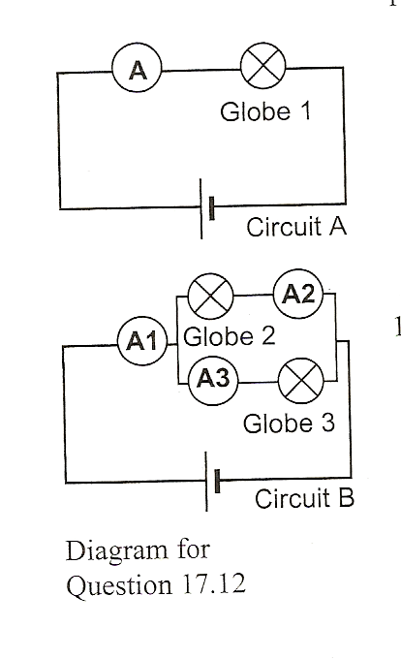17.12 A student sets up circuit A as shown in the diagram.The ammeter in the circuit reads 6.00 A. She then uses two globes identical to the one in the above circuit to connect circuit B, as shown in the diagram. Assume the resistance of the ammeter is negligible

[a] How does the resistance of circuit A compare to the resistance of circuit B?

**The resistance of the circuit B will be half of circuit A (parallel)**

[b] What readings would she find on the three ammeters in circuit B?

**V =V**

**6 x R = I x R/2**

**I = 12 A**

**A1= 12A**

**A2 = A3 = 0.5 A1 = 6A**

[c] How would the intensity of globes 2 and 3 compare with each other and with globe 1 in circuit I?

**The same intensity since equal current goes through each globe.**

17.13 Since car batteries are constructed from materials that possess non-zero resistance, it follows that real batteries possess *internal resistance.* We can think of a real car battery as an emf source with a small internal resistance, r, connected in series with an external resistance, R. We can represent the circuit as a whole by the relationship emf = I(r + R).

Hence, in order to understand fully any device in the car that is connected to the car battery, we need to understand that we always have a series circuit in which the resistance of the device being used is in series with the resistance of the power supply.

A typical car battery has an emf of 12 V, and must provide a current of 80 A to the starter motor.

[a] Why is the current the same through both the internal resistance and the external resistance?

[b] If the internal resistance is 0.050 , calculate the potential difference across this internal resistance when the starter motor is running.

[c] Why must the car battery have a very low internal resistance?

[d] Why is starting the car with the headlights on likely to affect their brightness? Use a circuit diagram in your answer.

17.14 One power supply can be used to supply electricity to a number of devices. As long as they are all connected in parallel, they all experience the same potential difference (potential drop). In the car, all of the lights are wired in parallel. One switch connects headlights and tail lights simultaneously so that four globes all light up together. Thus, they are all 12 V globes.

A car has two 60 W headlights and two 10 W tail lights.

[a] Calculate the total power consumption of the four lamps.

[b] Use the total power to calculate the total resistance of the four lamps when connected in parallel.

[c] Calculate the individual resistances of the 60 W lamps.

[d] Calculate the individual resistances of the 10 W lamps.

[e] Calculate the current supplied by the car battery when the car is parked but the lights are left on.

17.15 One way to make a set of fairy lights is to connect a number of 12 V lamps in parallel, and run the set from a 12 V transformer.

Alternatively, several low potential difference lamps may be connected in series until the combined potential difference across the lamps matches the power supply being used. For example, you could connect twenty 12 V lamps in series to a 240 V supply. This arrangement is shown in set A.

A third way is shown in set B below. Both set A and set B are made up of 15 lamps, and each set dissipates a total of 60 W. Thus each lamp in either

set is rated at 4 W.

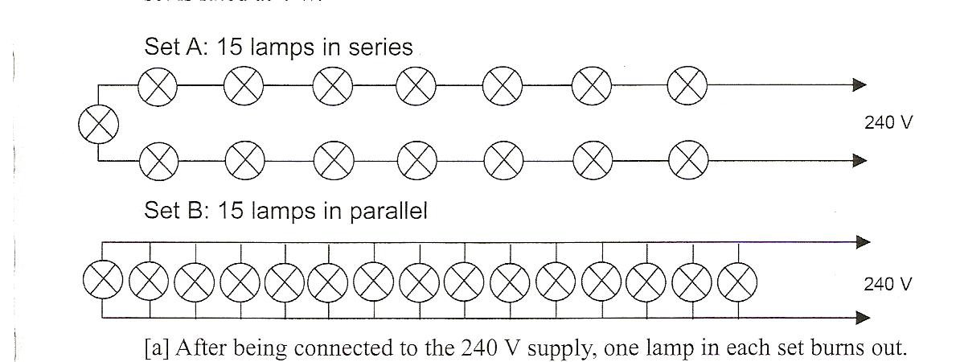

[a] After being connected to the 240 V supply, one lamp in each set bums out. Describe and explain the likely effect of this on the operation of each set of lights. [b] Calculate the resistance of each of the lamps connected in series in set A.

[c] Calculate the resistance of each of the lamps connected in parallel in set B.

[d] The user wants to replace the burnt-out lamps. By mistake, the lamps are interchanged (that is, a lamp from set B is placed in setA, and a lamp from set A is placed in set B). Describe what is likely to happen when each set is turned on again, and explain your reasoning.

* 1. Dry cells such as those used in torches, MP3 players and calculators have a significant internal resistance. Consequently we always have effectively a series circuit containing the emf of the battery, the resistance of the battery, and the resistance of the load such as the globe in the torch.

A hand-held flashlight uses two 1.5 V cells in series, yet has a globe rated at 2.5 V, 0.5 A.

[a] Draw a circuit diagram for this situation showing the emfs, the internal resistances and the globe.

[b] Explain how the potential difference across the lamp can actually be 2.5 V as rated.

[c] What is the internal resistance of each cell, supposing them to be identical?

* 1. A student experimenting with a solar cell connects a 1000 Q voltmeter across it and observes a potential difference of 1.0 V. Using a different, extremely high resistance voltmeter, the reading is larger (1.2 V).

[a] Account for this difference.

[b] Calculate the internal resistance of the solar cell.

**Set 18: Circuits and Safety**

* 1. Name and describe the function of each conductor in a three-wire domestic general power outlet (three-pin socket).

**Active Line with the high potential usually 240 Volts**

**Neutral Line at zero potential with respect to the active line.**

**Earth Line connected to the ground also at zero potential.**

* 1. The severity of an electrical shock depends on the **current** passing through a person. Why is it impossible to say which **potential differences** are dangerous?
  2. How many 40 W light globes can you operate on a 240 V circuit protected by a 15 A circuit-breaker?
  3. A car with a 12.0 V electrical system has 2.40 Q headlights. If you need to protect a single headlight circuit with a fuse, calculate the minimum current rating for such a fuse.
  4. Explain why:

[a] a short circuit is a thermal hazard instead of a shock hazard.

[b] alternating current is more dangerous than direct current at the same voltage.

[c] doubly insulated appliances reduce the need for a three wire system.

* 1. You plug a 1200 W heater into a 240 V general power outlet.

[a] What current will that heater draw?

[b] Could you plug two such heaters in an outlet protected by a 15 A circuit-breaker? Explain.

* 1. Should you operate a 1000 W iron, a 2400 W clothes drier and a 2000 W washing machine from the same 15 A 240 V power point? Explain.
  2. When electricity utilities install an electricity supply to a customer they sometimes install a fuse at the start of the line. If the wires to a customer's property have a larger than normal resistance, should the installers use a fuse with larger or smaller current rating?
  3. What role, if any, do circuit-breakers, fuses and residual current devices play in preventing shock hazards?
  4. The fuse in the lighting circuits of a house will break the circuit if the total current exceeds 10A and the fuse for the power points will break those circuits if the total current exceeds 15 A.

[a] How many 100 W light globes can be placed into one lighting circuit before the fuse will 'blow'?

[b] A 1800 W vacuum cleaner and a 2400 W clothes drier are used simultaneously on two sockets in the same power circuit. Will the fuse 'blow'? Explain.

[c] In the above two circumstances, what is the purpose of the fuse? [d] Explain why it is very silly to replace a blown fuse with a piece of thick copper wire.

[e] The fuse will always blow in the event of a short circuit. It is often claimed that this may prevent electrocution. Explain the circumstances under which a fuse might prevent electrocution.

* 1. Alec wants to connect several devices to one 240 V power board for a party. The devices are a 35 Ω heater, a 110 Ω lamp, a 750 Ω CD player, a 640 Ω cassette player, and a 350 Ω amplifier. The power board has an overload protection device that switches the board off when the total current exceeds 10 A. Will Alec's circuit work?
  2. Andrew foolishly uses a metal-handled knife to remove a burning slice of bread from his toaster. The knife touches the toaster element, which carries 240 VAC. Fortunately for him, a residual current device (RCD), also known as a 'safety switch', is installed in his home. His body resistance would allow 40 mA of current to pass through him to the earth. This is enough current to trip the RCD, which switches off all power in his house.

[a] What was the total resistance of Andrew's body, shoes and floor?

[b] If the current was 1.50 A in the active line, what would the 'return current' in the neutral line be for the RCD to detect the difference?

* 1. It is common practice in commercial installations to have a separate circuit for a refrigerator so no other appliance can trip the circuit-breaker and shut off the fridge. However, Jill turns on a 1.5 kW griller on the same circuit at the same time as a fridge that draws 10.0 A when it starts. A 15.0 A circuit-breaker protects the fridge circuit.

[a] Calculate the current drawn by the griller.

[b] What is the resistance of the fridge as it starts up?

[c] Will the circuit breaker be activated when the fridge starts up?

* 1. Some school laboratories have EHT (Extra High Tension) power packs that can give up to 3000 V. For safety, they are provided with a 50 MΩ resistor in series with the supply.

[a] What is the maximum current able to be supplied by this power pack?

[b] Estimate the potential difference there would be across a 3 V, 500 mA torch bulb connected across such a supply.

[c] Explain how the 50 MΩ resistor acts as a safety device.

* 1. John is barefoot on a wet laundry floor. His right hand accidentally touches a frayed live 240 V AC wire. John's body has a resistance of 4400 Ω0 to ground. He has not protected his house with a residual current device (RCD).

[a] What current will flow through him?

Carmen tries to rescue John without first switching off the power. She grabs his left wrist. Carmen has a resistance of 8000 Ω and the resistance of John's body between the wire and his left wrist is 400 Ω.

[b] Does the current through John's heart increase, decrease or stay the same?

[c] What current will flow through Carmen?

[d] What should Carmen have done?

[e] Explain why the fuse in the house circuit was no protection against electrocution.